Running a job to Remove “Technical – Migration” Item Process Type
- Use Alma Admin to
  - Manage sets
  - Run a job
  - Manage jobs
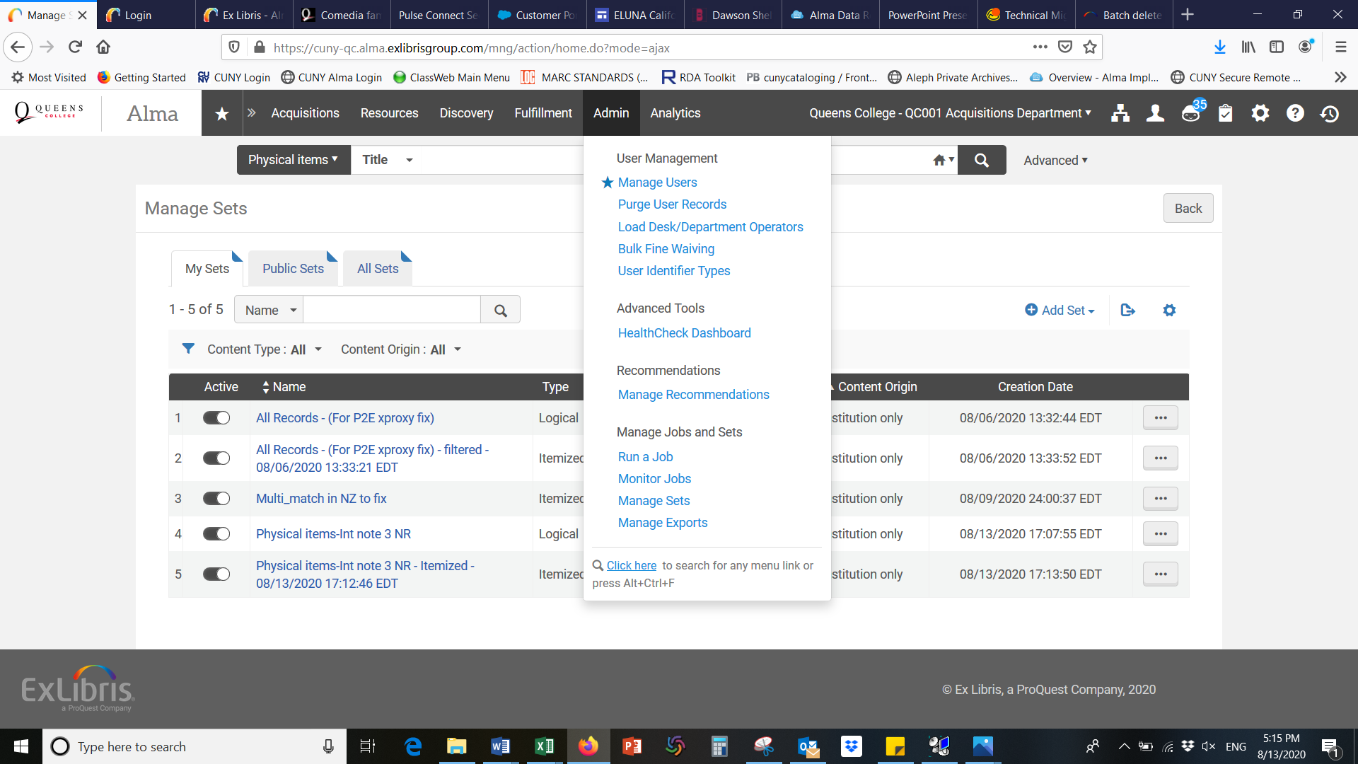

- Running a job procedures
  - To create a set (Itemized set) – from “Save Query” (saving Alma search results)
  - To select a job to run

To handle “Technical – Migration” process type, you’ll need to create multiple sets of records – each set represents a separate Aleph Process Status. Examine and resolve each first. When all records are resolved and the remaining records are in place, you can following the instructions below to batch remove the Technical Migration process type.
Batch handling “Technical Migration” records
- Create a set – needs to be a “Physical Items” set
Use “Physical Items” using Alma Advanced Search. Select criteria “Process Type” and “Internal note 3” (to identify specific Aleph IPS).
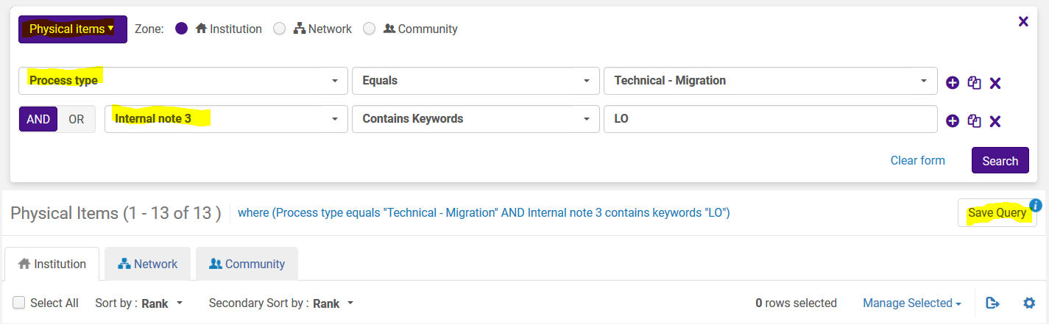

Create a set by clicking “Save Query” (logical set). Give a name of this set.
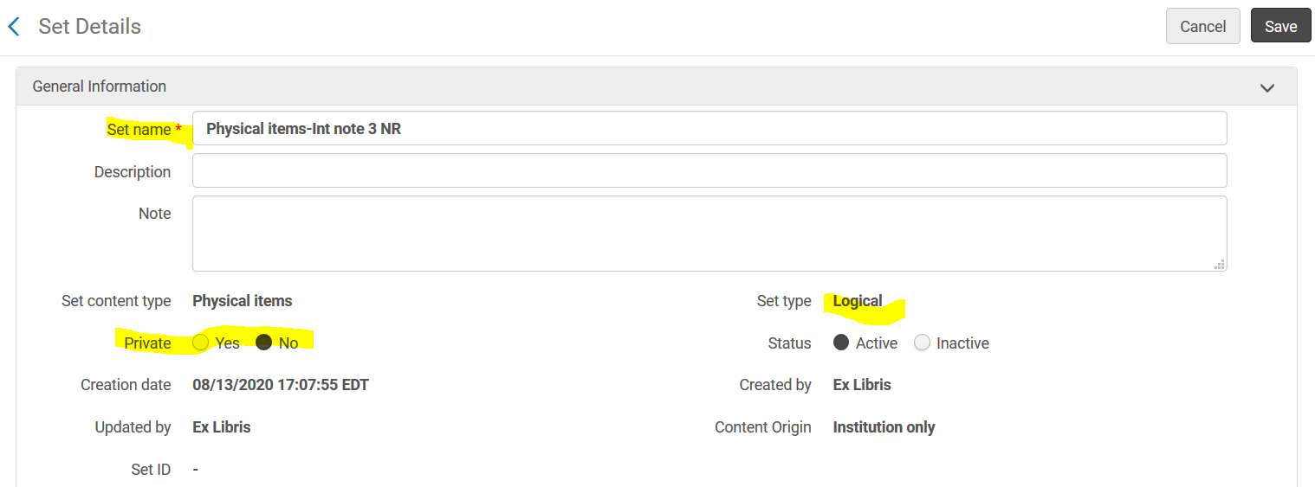
A logical set is now saved.
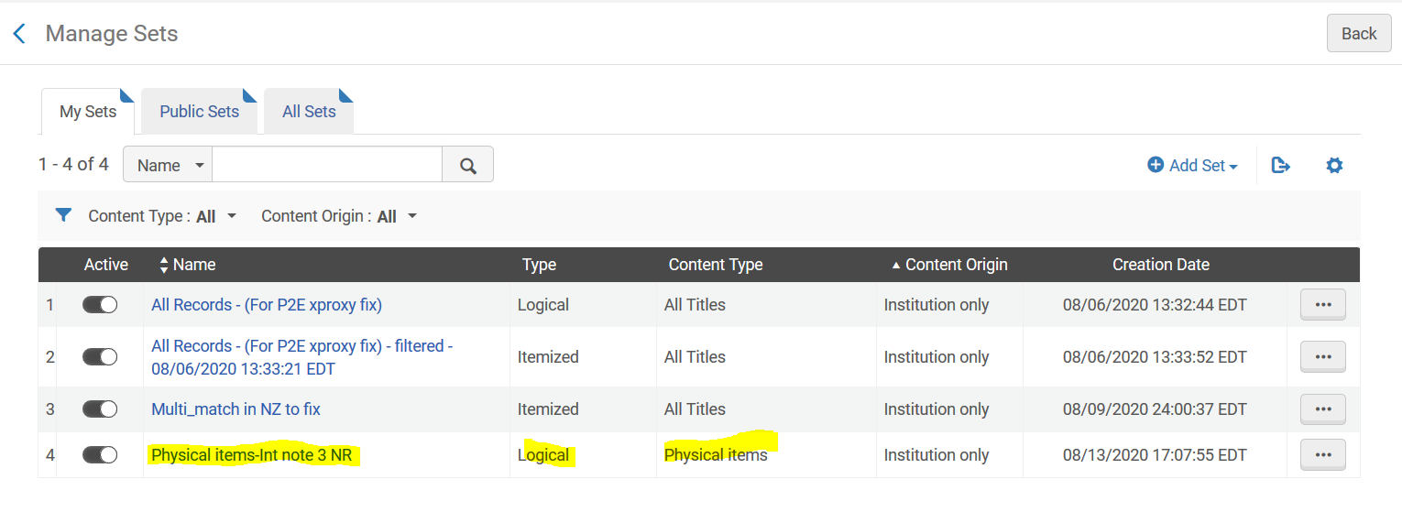
Convert the logical set to “Itemized” set.
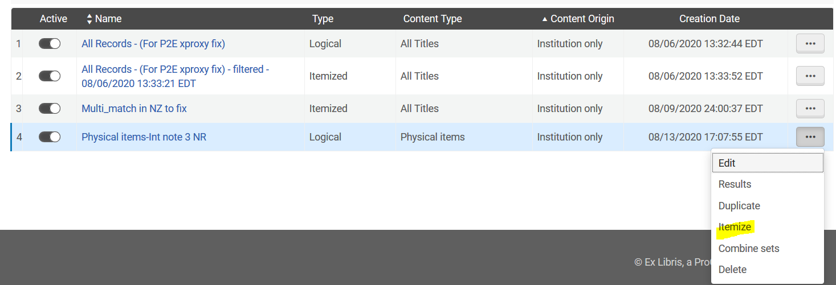
Submit to save the itemized set.
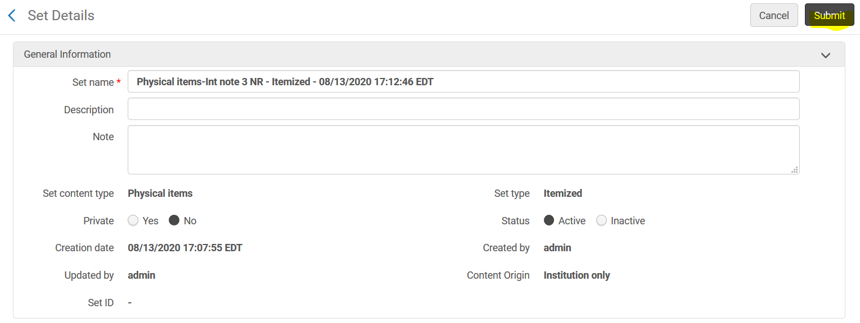
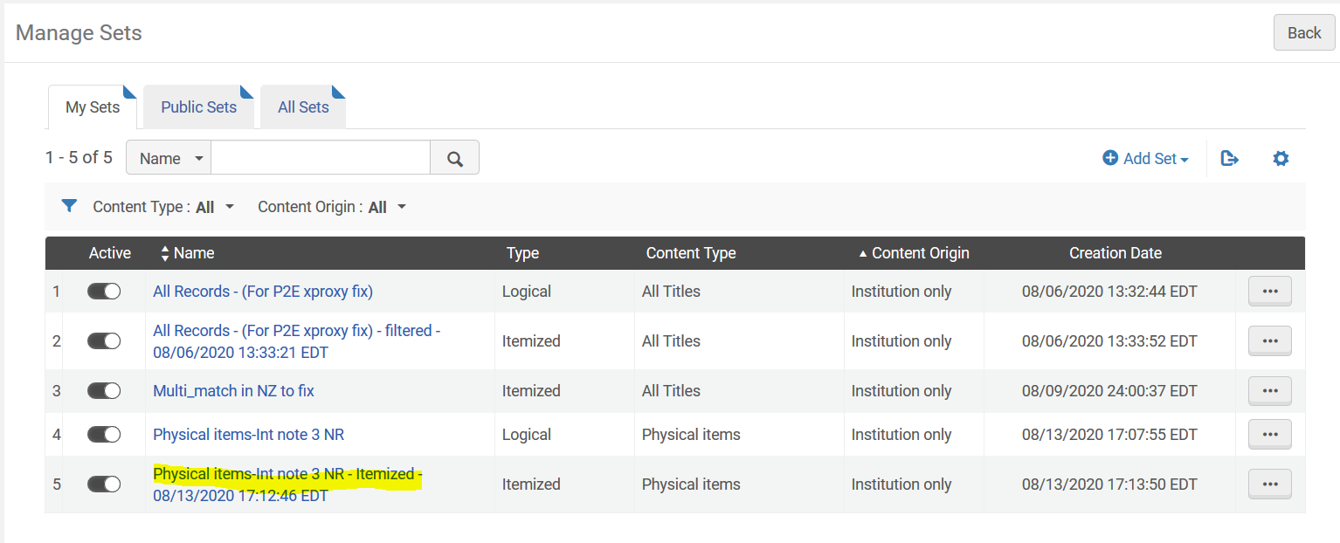
To run a job, open the jobs list from “Admin” on the main menu bar. A list of Alma jobs will display.
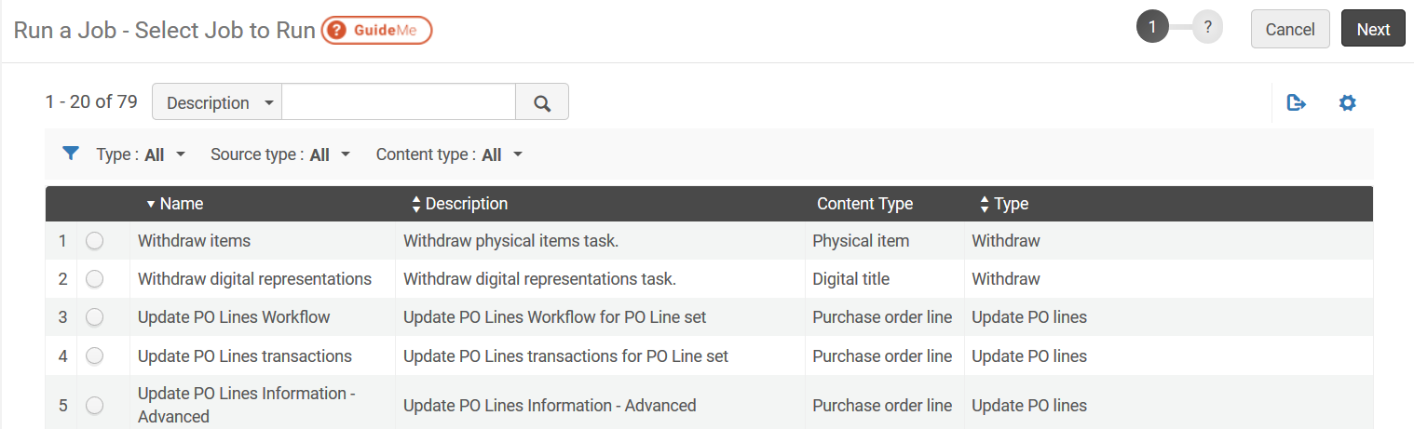
Use the search box to narrow down applicable jobs.
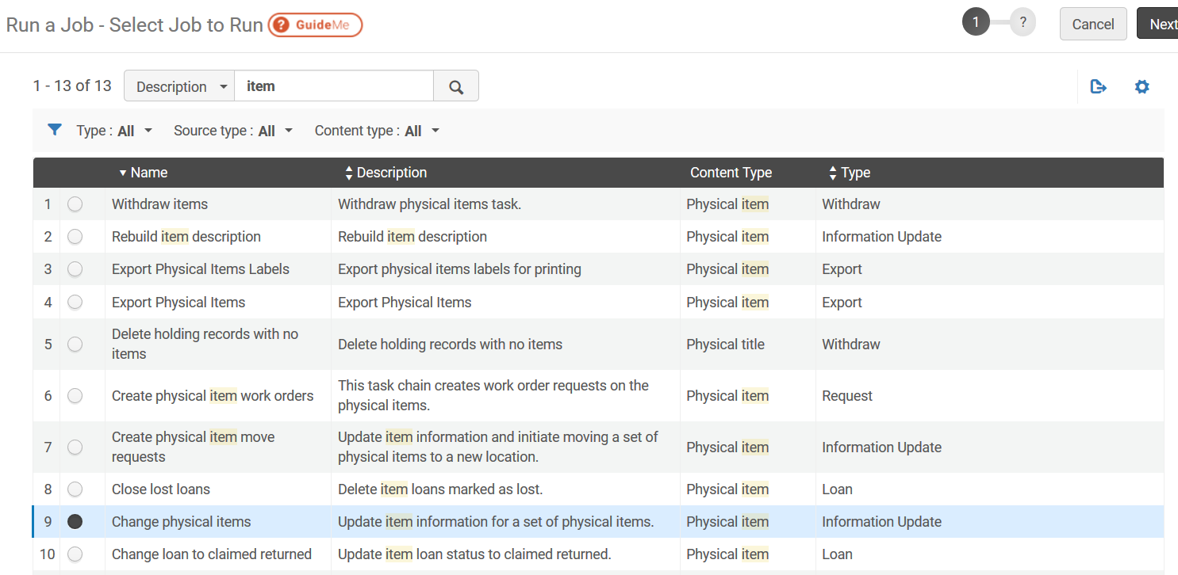

Select the job and click Next.
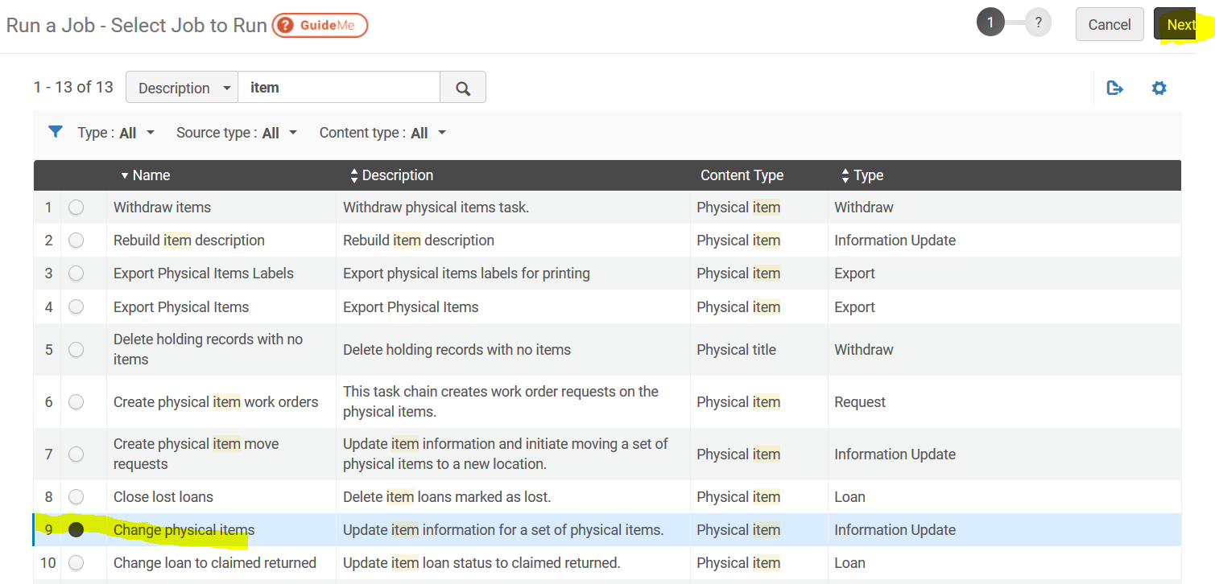

Select a set to run the job –
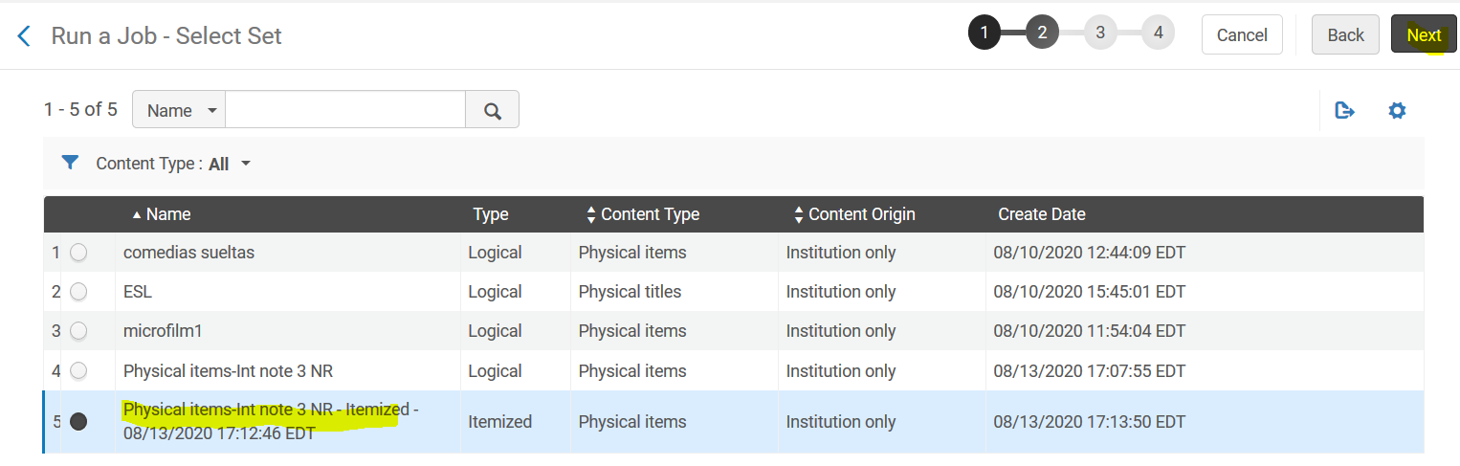

The taks parameters screen will display. Locate the Missing Status under “Change General Information” and click next to submit andcomplete the job.
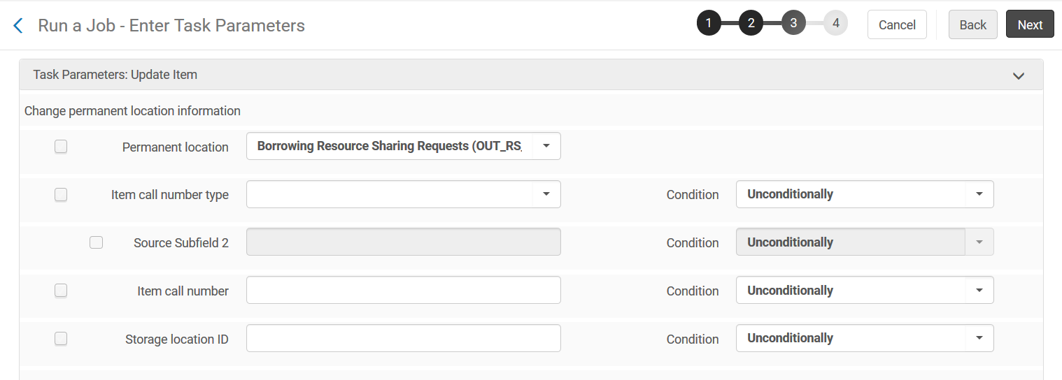
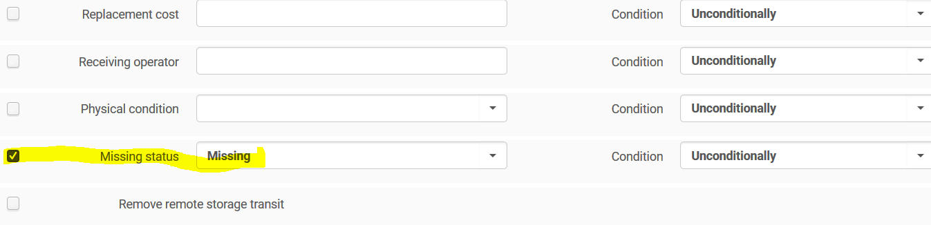
Run the “Change Physical Item” job again (2nd time) to leave the missing status blank.

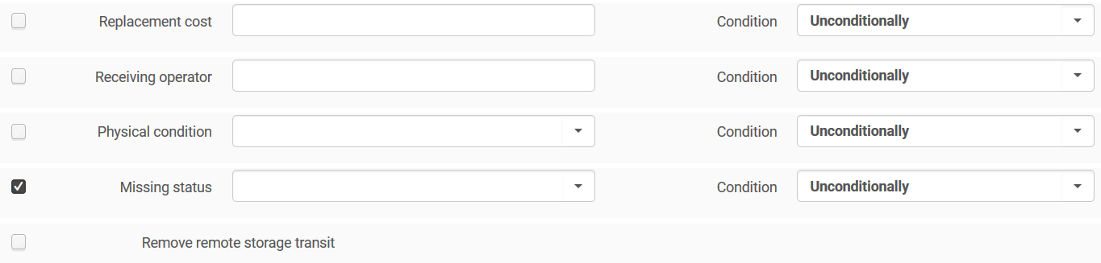
After running the job the 2nd time, the records should be “in Place” status.

