On OCLC Connexion
Configuration>General>External Systems>Integration Profiles
On Connexion Client, Menu bar
- Click Tool > Options
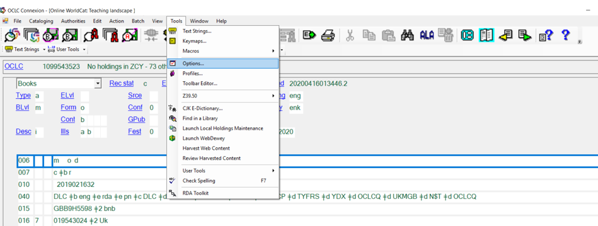

- With the Options window, click “Export” to access export option. Click “Create” to create a new path to export to NZ or IZ. (Note: If you have already created the path and want to edit the setting, click “Edit” and go to step 5.)
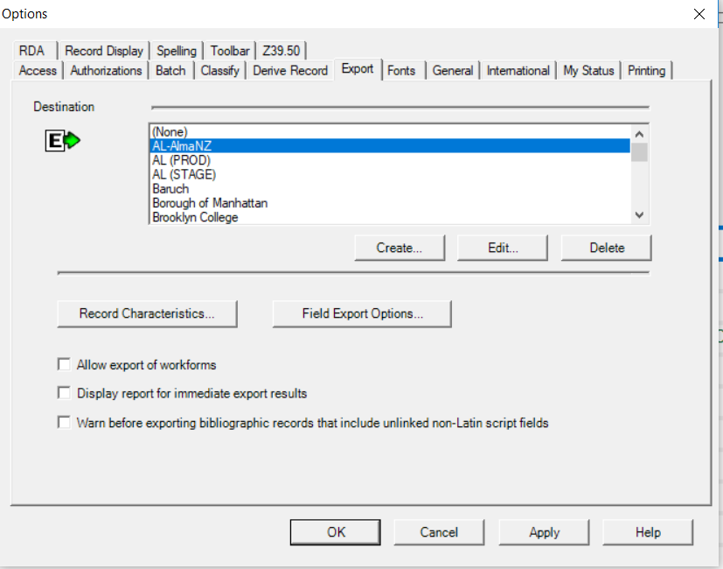

- You’ll be promoted with the window “New Export Destination”. Click “OCLC Gateway Export” and click “OK”.

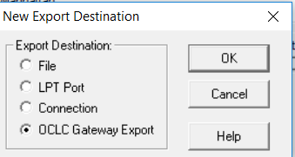

- Then next window is the Local System Settings. Fill out the “Host name” as given in the next image. Check “Send Local System Logon Id and Password” to activate the “Local System Authorization” setting.
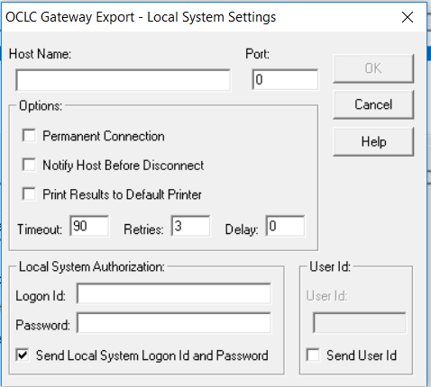

- Fill out all the elements as given below. Click OK when you finsih.
Host Name: cuny-network.alma.exlibrisgroup.com
Logon Id: 01CUNY_NETWORK
Password: Ask OLS (support@cuny-ols.libanswers.com)
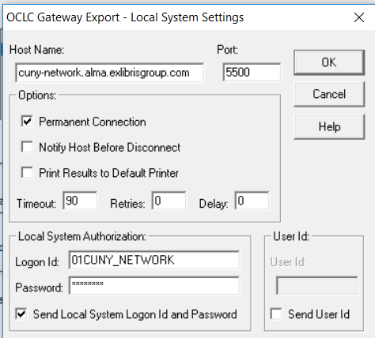
- The last step is to give a name for the Export Destination. You can given a name at your wish. A good name will be “Alma-NZ”. Click “OK” when you are done.
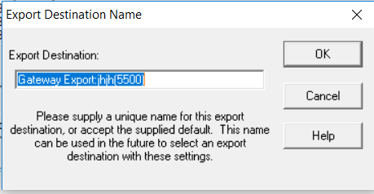
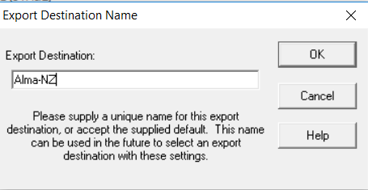

- Select this Alma-NZ gateway when you want to export records to CUNY Alma NZ. (i.e., click the gateway so it is highlighted.) Click “Apply” and Close.
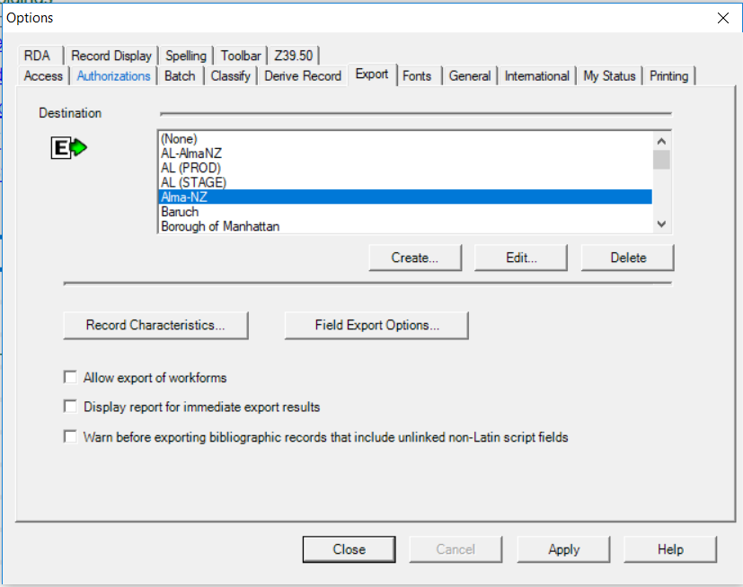

- If setting is done correctly. When you export a record to Alma NZ, the message will be like this.
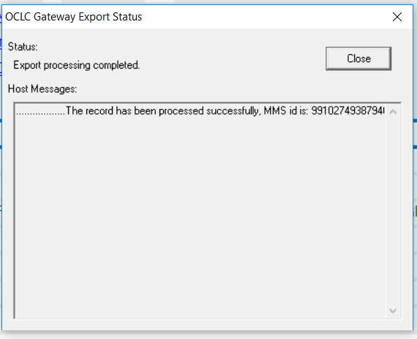

IZ Gateway setting (example of Baruch’s export gateway).
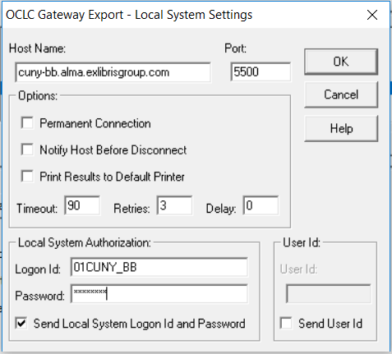

Institution Code | Alma Host Name
01CUNY_BB | cuny-bb.alma.exlibrisgroup.com
01CUNY_BX | cuny-bx.alma.exlibrisgroup.com
01CUNY_BC | cuny-bc.alma.exlibrisgroup.com
01CUNY_SI | cuny-si.alma.exlibrisgroup.com
01CUNY_GJ | cuny-gj.alma.exlibrisgroup.com
01CUNY_LG | cuny-lg.alma.exlibrisgroup.com
01CUNY_JJ | cuny-jj.alma.exlibrisgroup.com
01CUNY_KB | cuny-kb.alma.exlibrisgroup.com
01CUNY_CL | cuny-cl.alma.exlibrisgroup.com
01CUNY_NC | cuny-nc.alma.exlibrisgroup.com
01CUNY_HO | cuny-ho.alma.exlibrisgroup.com
01CUNY_HC | cuny-hc.alma.exlibrisgroup.com
01CUNY_LE | cuny-le.alma.exlibrisgroup.com
01CUNY_ME | cuny-me.alma.exlibrisgroup.com
01CUNY_NY | cuny-ny.alma.exlibrisgroup.com
01CUNY_QC | cuny-qc.alma.exlibrisgroup.com
01CUNY_CC | cuny-cc.alma.exlibrisgroup.com
01CUNY_YC | cuny-yc.alma.exlibrisgroup.com
01CUNY_GC | cuny-gc.alma.exlibrisgroup.com
01CUNY_BM | cuny-bm.alma.exlibrisgroup.com
01CUNY_QB | cuny-qb.alma.exlibrisgroup.com
01CUNY_AL | cuny-al.alma.exlibrisgroup.com
01CUNY_NETWORK | cuny-network.alma.exlibrisgroup.com

