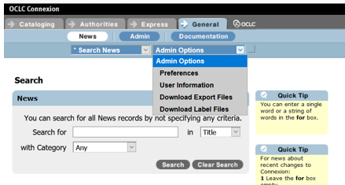

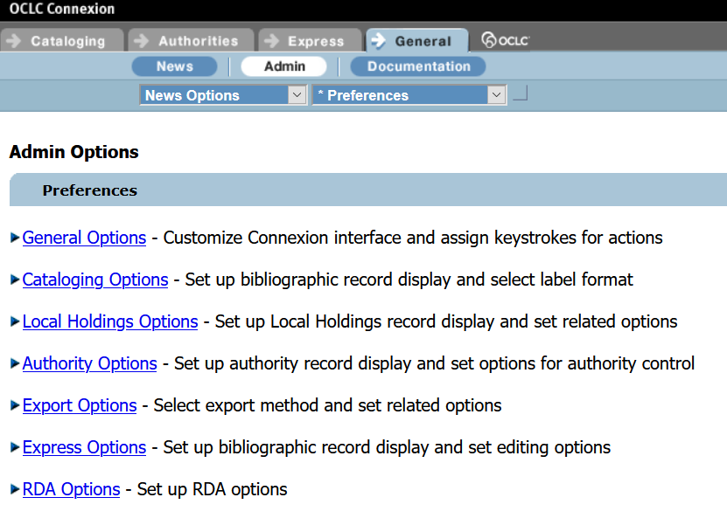

Fill out all the elements as given below. Click OK when you are done.

Host Name: **cuny-network.alma.exlibrisgroup.com**

Port number: **5500**

Logon Id: **01CUNY_NETWORK**

Password:Ask OLS (support@cuny-ols.libanswers.com)

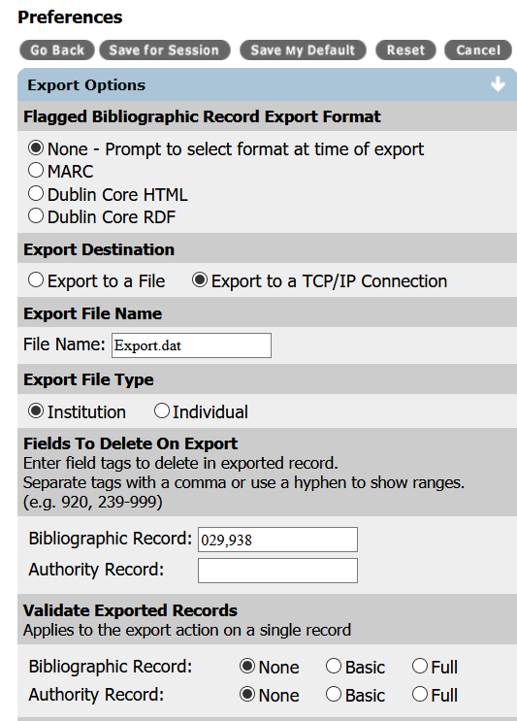

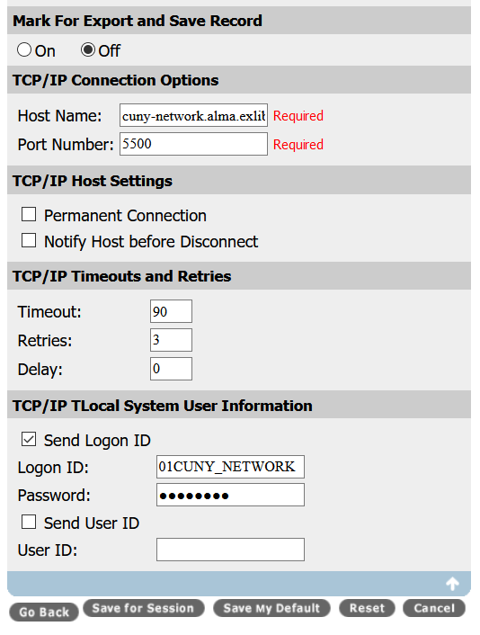

Click “Save My Default”

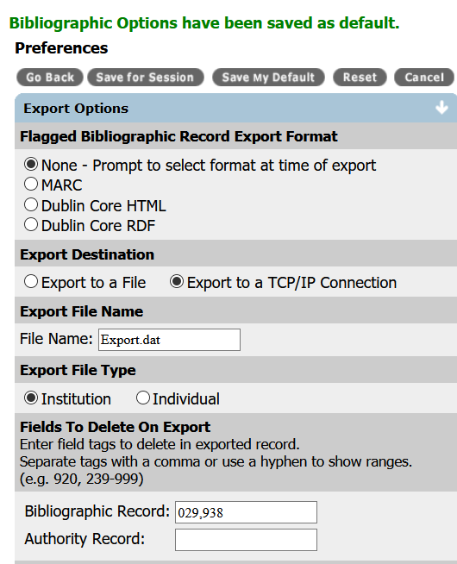

Go back to cataloging

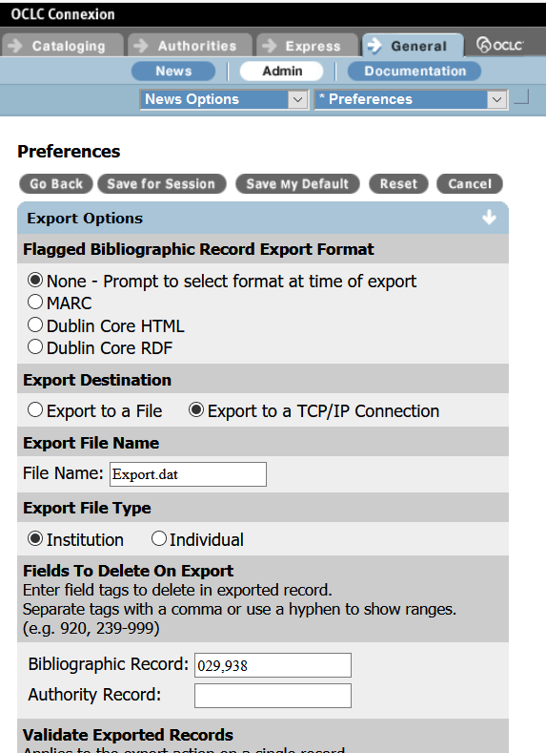

Search Connexion and test exporting a record.

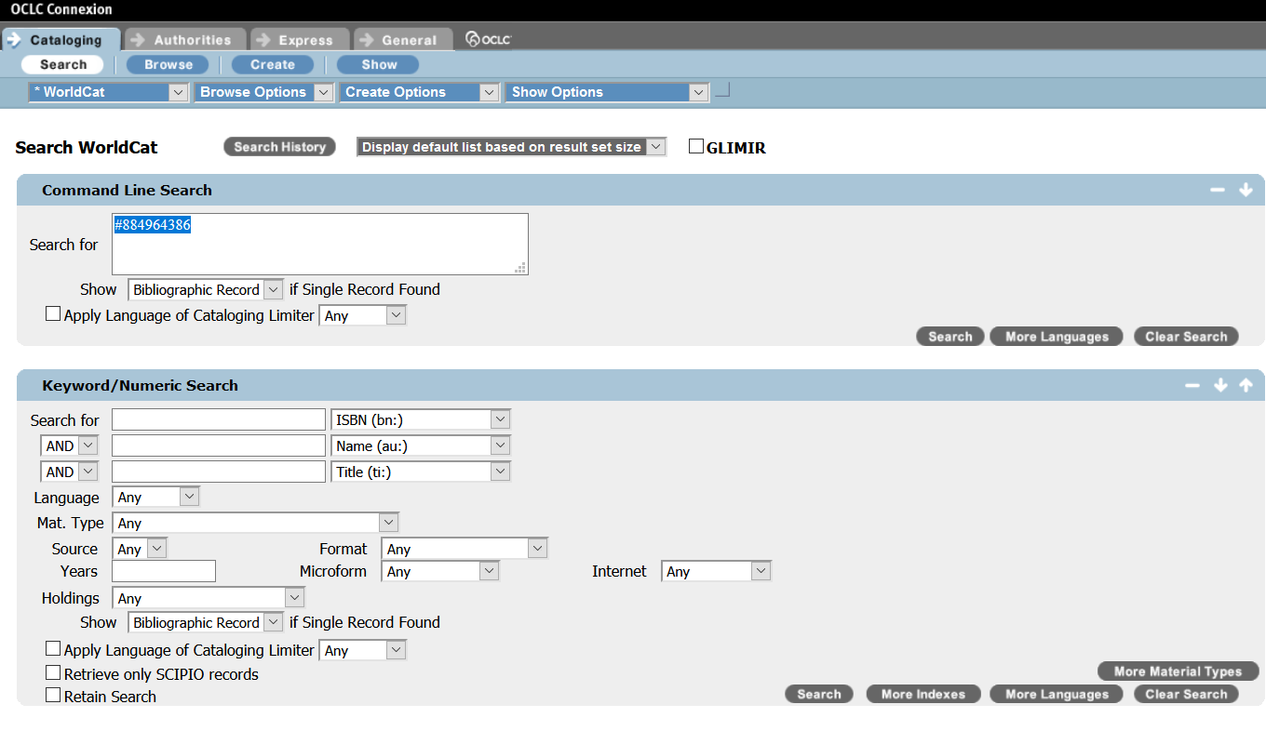

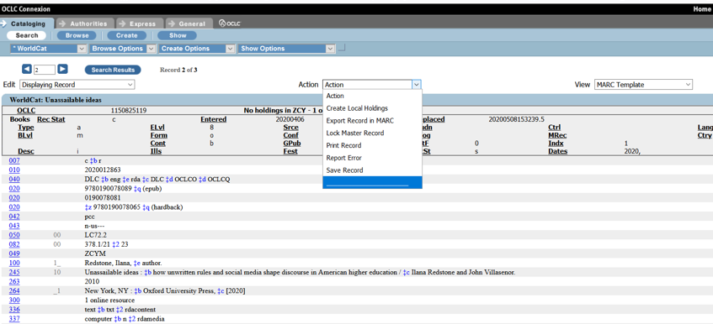

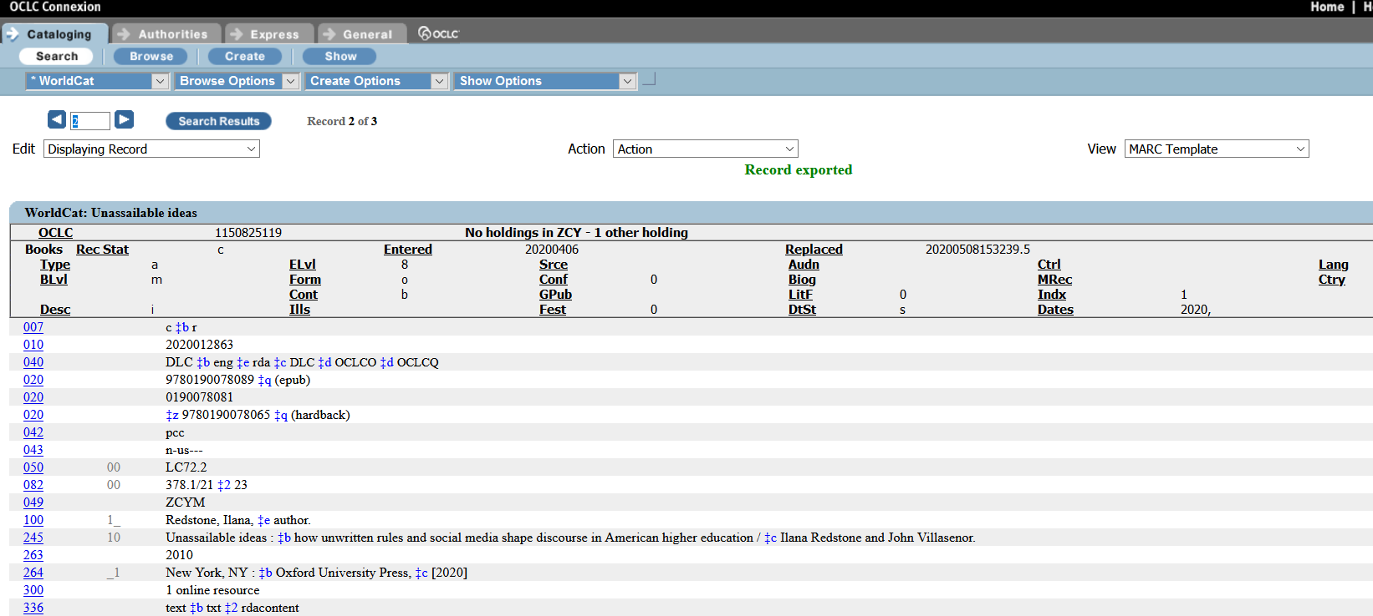

Exported and saved in Alma NZ

