Installing OCLC Connexion on Any PC
Guide by Rebecca Hyams, June 2020

This is a guide to walk you through installing and configuring OCLC Connexion on any PC. You do not need any special settings on configurations to run it, but Connexion only runs in Windows. If you’re using a Mac or something like a Chromebook, you need to use Connexion Browser (see link further down below).

To Install Connexion
Go here: https://help.oclc.org/Librarian_Toolbox/Software_downloads/Cataloging_software_downloads.
- You’ll have to check the box to accept their license agreement and you’ll want to download the one called Connexion client 2.63 complete software.
- Install like any other program on your computer

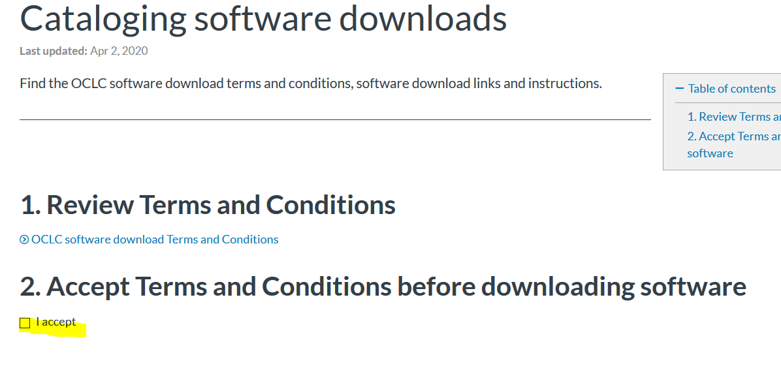
You’ll need to check “I accept” to be able to access the list of softwares.

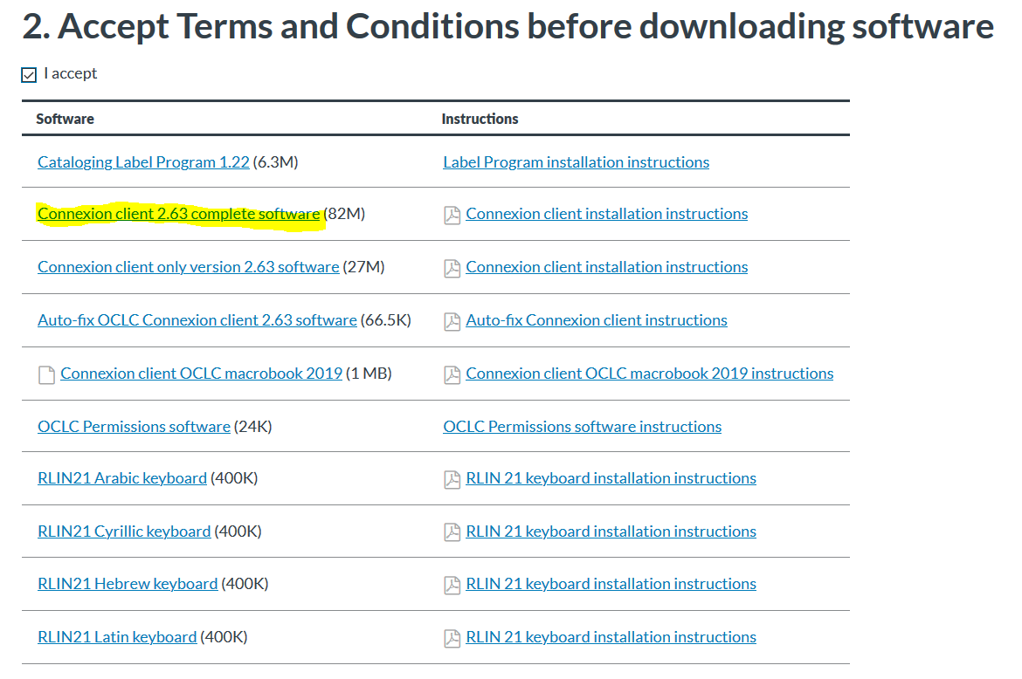

Set Up Your Login
Once you install it and launch it you’ll need to do the following:
- On the menu bar on the top of the screen, go to Tools >> Options
- Go to the Authorizations tab
  - For authorization number put [Your OCLC Authorization number]
  - For password put [Your OCLC Authorization password]
  - Give it a name (I call it default)
  - If you don’t have yours, or forgot, Cathy has them for every library

Set Up Export to Alma
- (See Cathy’s documentation about configuring export to the Alma NZ and your library’s IZ)

Connexion Browser (for Mac/Chromebook users and anyone who can’t install on their PC)
The web-based Connexion (a little fussier to work with) is here: http://connexion.oclc.org/ (use the same authorization number and password as above.)

